Gongcha Label Printer Configurations
1. Make sure to change the format if not using SuperWu 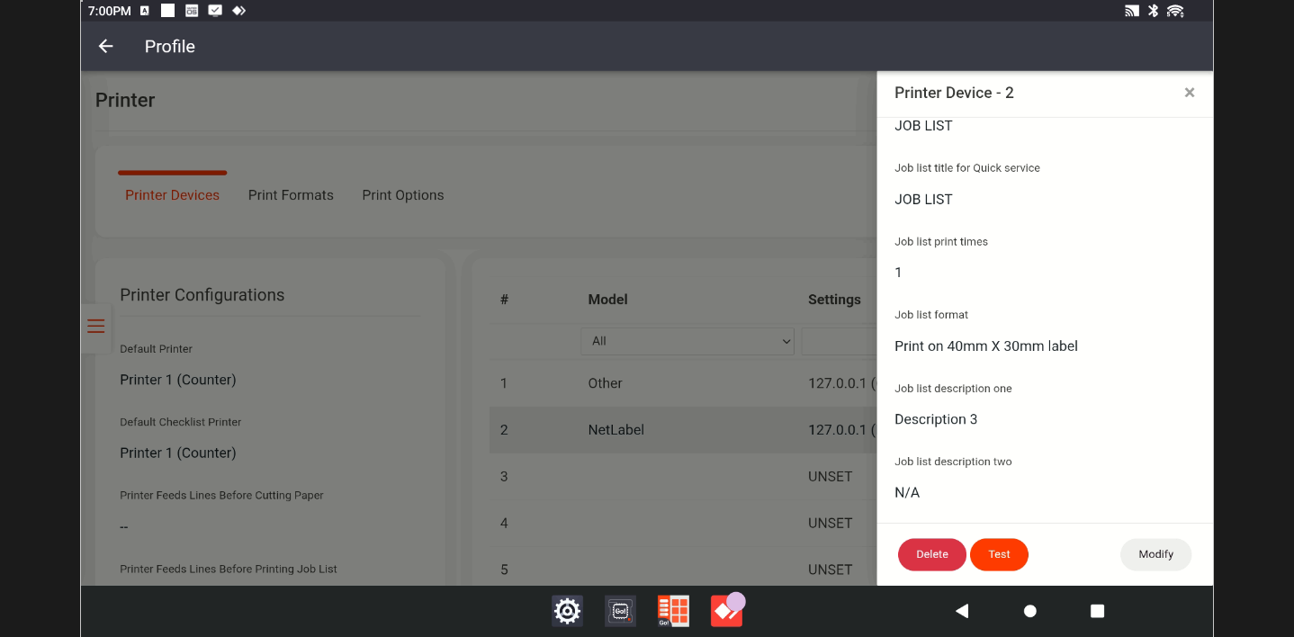
- Test Printer to adjust
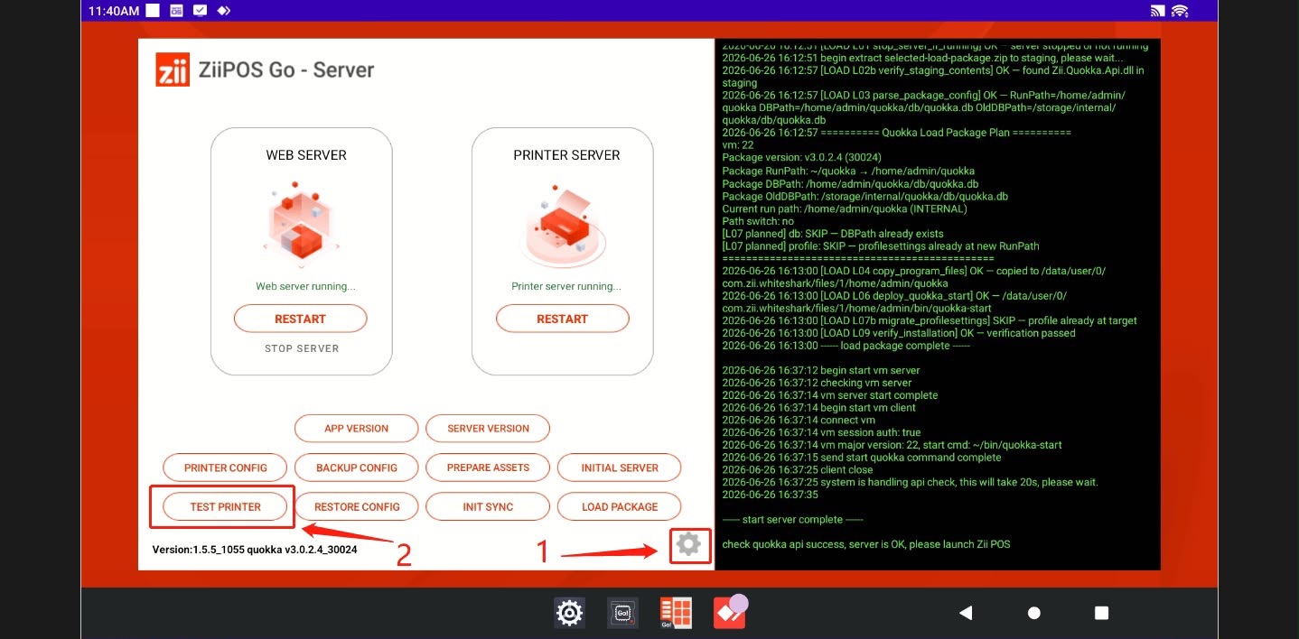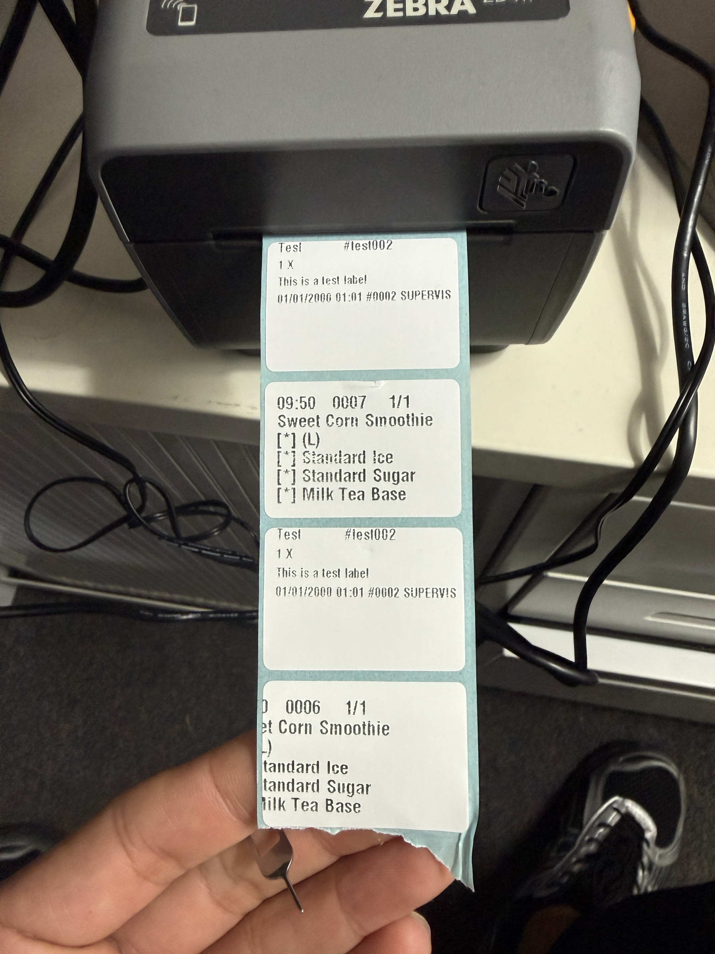
3. If printing still doesn’t adjust, reset zebra printer.Use press a pin to press and hold for 10 seconds and release 